**Task**

Create a React Application “eventexamplesapp” to handle various events of the form elements in HTML.

1. Create “Increment” button to increase the value of the counter and “Decrement” button to decrease the value of the counter. The “Increase” button should invoke multiple methods.
   1. To increment the value
   2. Say Hello followed by a static message.
2. Create a button “Say Welcome” which invokes the function which takes “welcome” as an argument.
3. Create a button which invokes synthetic event “OnPress” which display “I was clicked”
4. Create a “CurrencyConvertor” component which will convert the Indian Rupees to Euro when the Convert button is clicked.
5. Handle the Click event of the button to invoke the handleSubmit event and handle the conversion of the euro to rupees.

**App.ja**

import EventHandling from './Ex-11/EventHandling';

import CurrencyConvertor from './Ex-11/CurrencyConvertor';

function App() {

    return(

        <>

            <EventHandling/>

            <CurrencyConvertor/>

        </>

    );

}

export default App;

**EventHandling.js**

import { useState } from "react";

export default function EventHandler(){

    const [counter, setCounter] = useState(0);

    const handleIncreament = () => {

        setCounter(counter + 1);

        alert('Hello! Dear')

    };

    const handleDecreament = () => {

        setCounter(counter - 1);

    }

    const handleWelcome = (msg) => {

        alert(msg);

    }

    const handleClick = () => {

        alert("I was clicked");

    }

    return(

        <div>

            <h2>{counter}</h2>

            <br/>

            <button onClick={handleIncreament}>Increament</button>

            <br/>

            <button onClick={handleDecreament}>Decreament</button>

            <br/>

            <button onClick={() => handleWelcome('Welcome !')}>Say welcome</button>

            <br/>

            <button onClick={handleClick}>Click me</button>

        </div>

    );

}

**CurrencyConvertor.js**

import React, { useState } from 'react';

export default function CurrencyConvertor() {

    const [amount, setAmount] = useState('');

    const [currency, setCurrency] = useState('Euro');

    const handleSubmit = (e) => {

        e.preventDefault();

        alert(`Converting to ${currency} \n Amount is ${amount * 80}`);

    };

    return (

        <div style={{ margin: '20px' }}>

            <h1 style={{ color: 'green' }}>Currency Convertor!!!</h1>

            <form onSubmit={handleSubmit}>

                <label>

                    Amount:

                        <input

                            type="number"

                            value={amount}

                            onChange={(e) => setAmount(e.target.value)}

                        />

                </label>

                <br /><br />

                <label>

                    Currency:

                        <input

                            type = 'text'

                            value = {currency}

                            onChange={(e) => setCurrency(e.target.value)}

                        />

                </label>

                <br /><br />

                <button type="submit">Submit</button>

            </form>

        </div>

    );

}

**Output**

(On clicking “Increament” button)

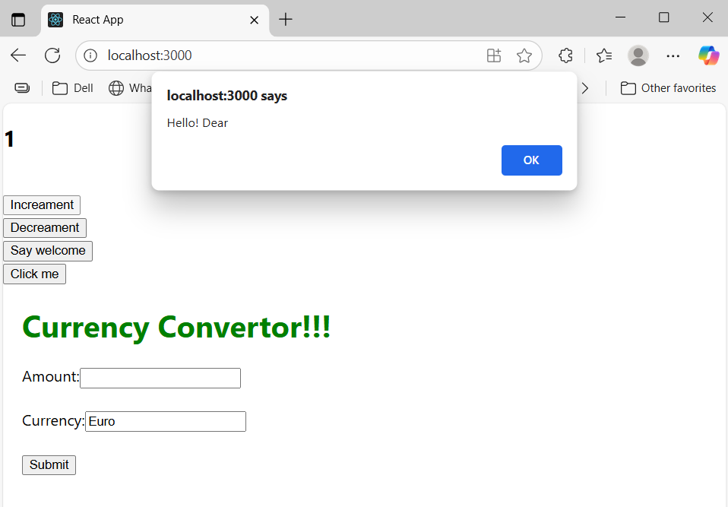

(On clicking “Decreament” button)

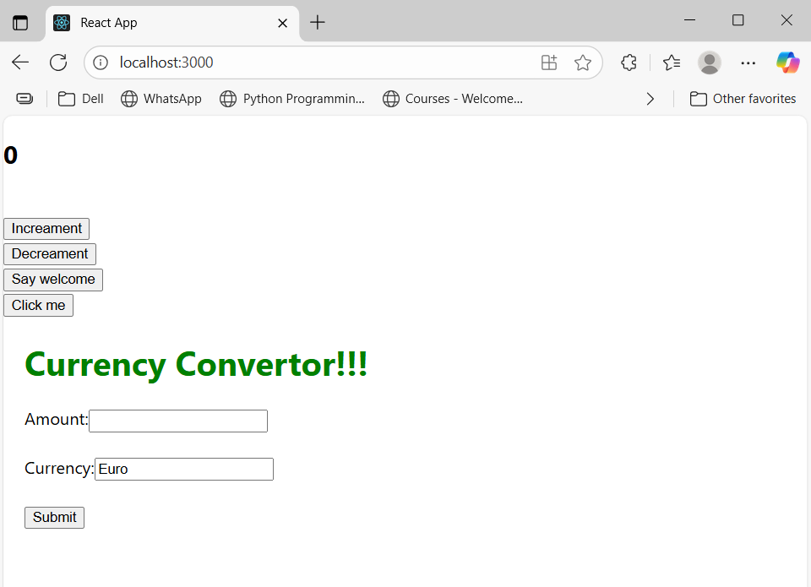

(On clicking “Say welcome” button)

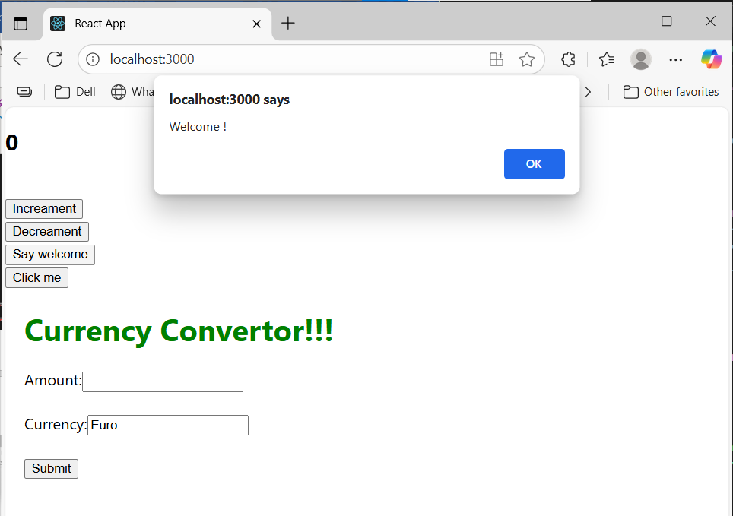

(On clicking “Click me” button)

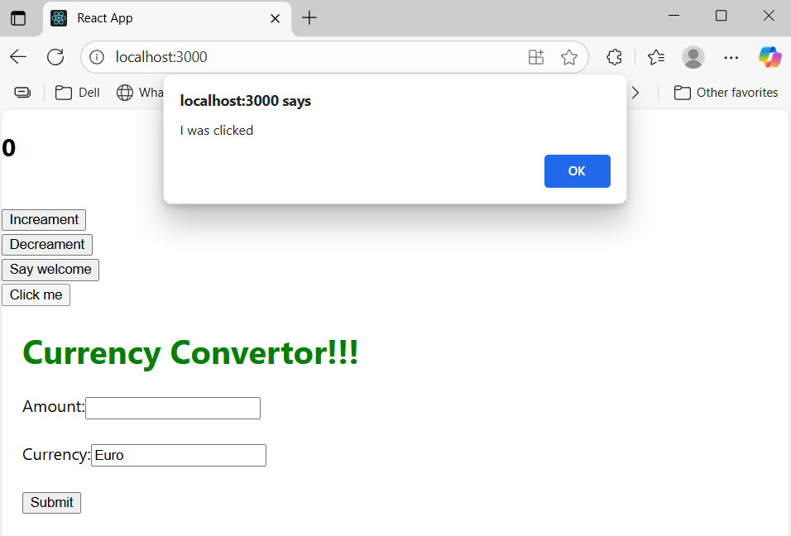

(Using the Currency Convertor)

